Development of Yolov8
- Data Cleaning
  - Before starting the development work of yolov8, it is necessary to clean the data. The data collected in the early stage is scattered in different folders, and some of the labels of the data have some errors, and some data is duplicated in different folders, which will have a negative impact on the model.
  - After sorting and checking, I integrated these data into the standard yolov8 format, four folders: images/train, images/val, labels/train, and labels/val. There are a total of 2395 images in the training set and 518 images in the validation set.
  - I rewrote a dataset definition yaml file and defined the paths and classes inside it, as shown in the following figure:
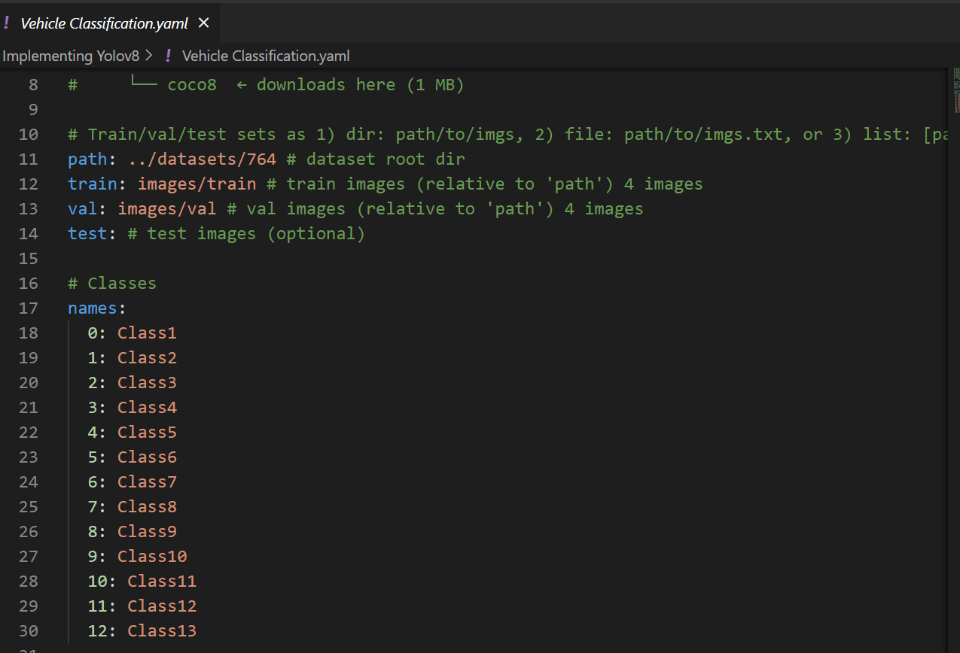
- Model Training:
  - The inference time of Yolov8n only reduced by 20%, but the accuracy decreased significantly. Yolov8M and yolov8L is big for real-time solution, 100% more inference time cost. So I chose the backbone network of yolov8s.
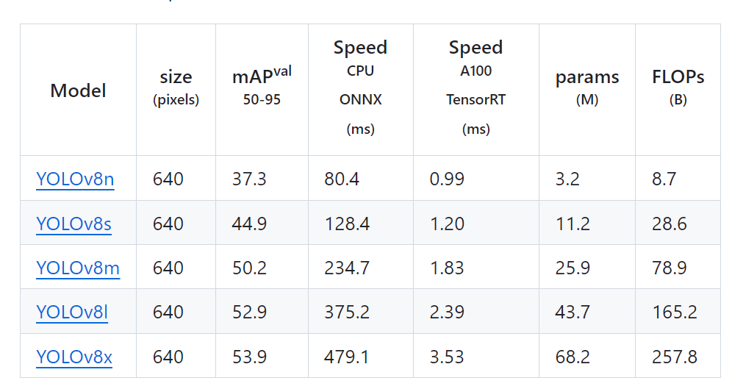
  - Benefiting from the relatively complete API of yolov8, I only need a small amount of code to start the training. I defined 200 epochs and a batch size of 16, and started the training.
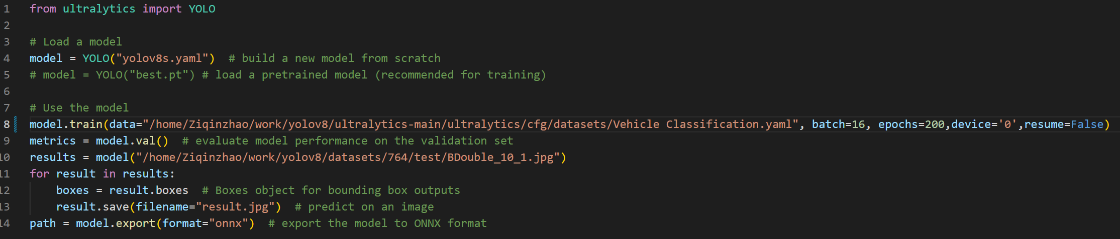
  - After training, the model achieved an mAP50 accuracy of 85.7% on the current dataset. In terms of classification, classes 10 and 11 have the highest accuracy, which I believe is related to the quality of the images collected and the size of the vehicles in the images.
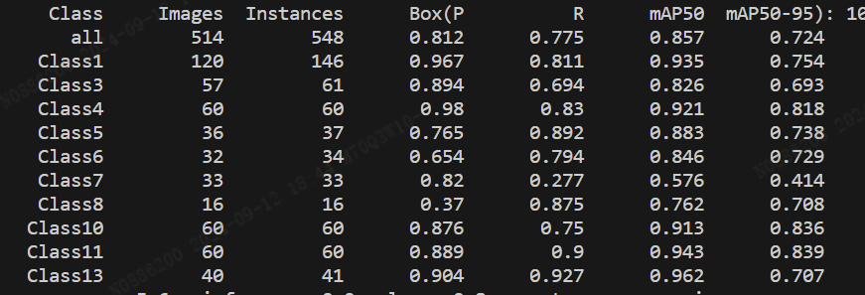
- Model Testing:
  - After the training was completed, I downloaded a video of a truck shot from YouTube and tested the video. The model is effective in recognizing the type of truck, as shown in the following figure, where the category of double road train (class 11) is identified.
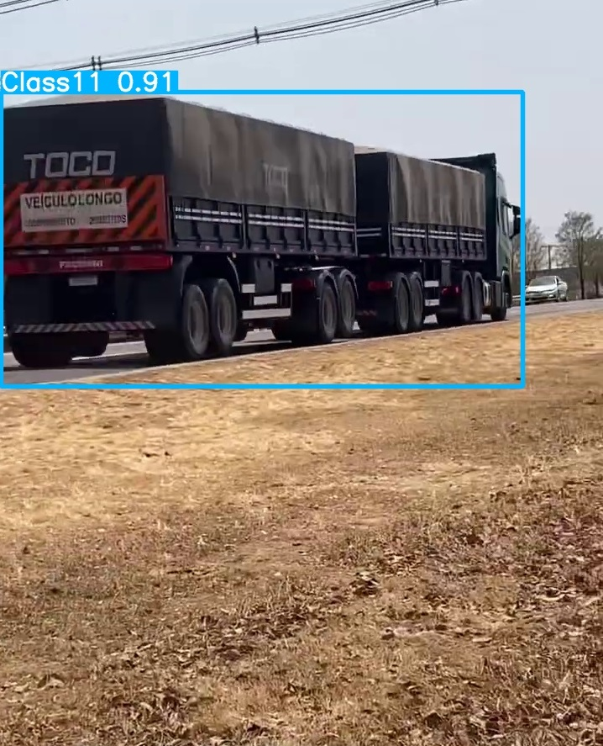
  - But at the same time, I found that when the truck passed in front of the photographer and only a part of the truck could be seen, without the full view, the model would be confused with other categories. As shown in the following figure, only the front of the truck and the 3 axles of the first carriage could be seen, and it was mistakenly recognized as class 8.
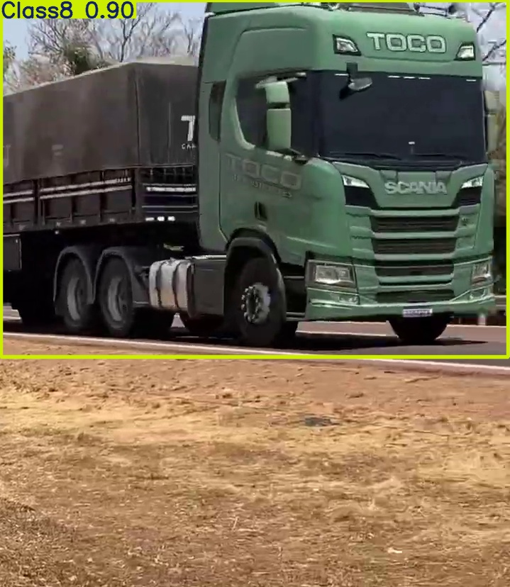
  - This indicates that in actual scenarios, the shooting angle of the camera needs to be considered. For example, the viewing angle should be larger to be able to capture the full view of the truck. Also, not every position where the vehicle passes can be used for detection. For example, shooting from the front and rear of the vehicle would be more suitable.
Advanced Development of Yolov8 - Depth Estimation
- Selection of Depth Estimation Schemes
  - Depth measurement can be carried out through different devices, such as binocular cameras, depth cameras, etc. However, these schemes all require the combination of at least two cameras and involve complex calibration, which is difficult to achieve for the common surveillance cameras in current road monitoring. Therefore, I chose monocular depth estimation as the implementation method. This method only requires one camera and can be conveniently implemented in the existing road monitoring, but the accuracy of monocular depth estimation is a big challenge.
  - Benefiting from the large-scale development of AI technology in recent years, the accuracy of monocular depth estimation has also been greatly improved. I chose one of them: depthanything-v2. It was released by Tiktok and HKU and is an efficient AI depth estimation scheme that emerged in 2024.
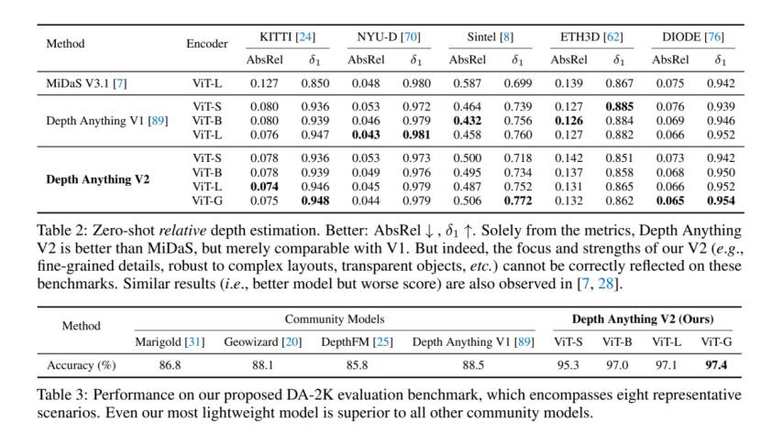
- Function Implementation
  - Process Design. I need to embed the depth estimation process into yolov8, as shown in the following figure:
    - The input image will be sent to the yolov8 and DepthAnythingv2 models respectively to obtain the vehicle target box and the depth estimation map.
    - Map the target box to the depth map to find the maximum and minimum values of the depth within the target box, and the minimum value represents the closest distance between the target vehicle and the camera.
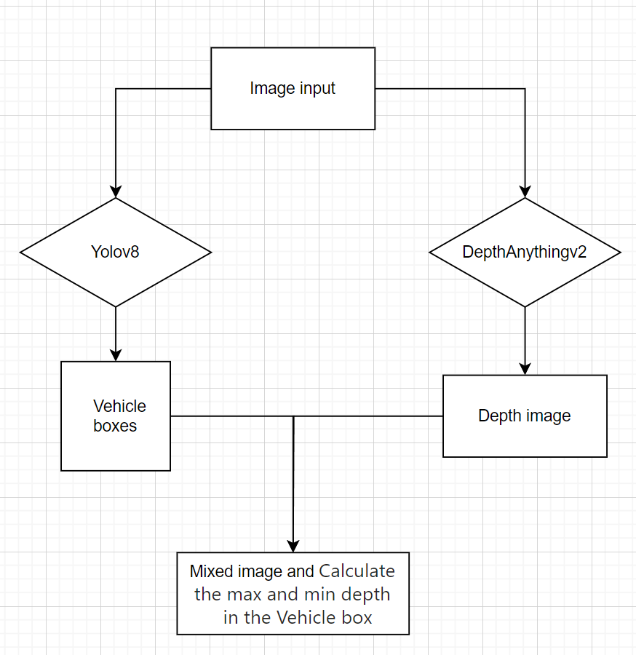
- Code Implementation.
  - Benefiting from the fact that DepthAnythingV2 has already provided a pre-trained model completed on a large amount of data, it can be directly used for inference. There are two branches under this project. The default branch obtains the relative depth value, which has a better visualization effect and can be used for qualitative evaluation. The other branch is the metric branch, which has calibrated the actual distance for different indoor and outdoor scenarios and is suitable for quantitative evaluation. In order to have a better visualization effect, I stitched the detection results of yolov8 and the depth test results together and printed the distance results on the image.
Box mapping and image contact：  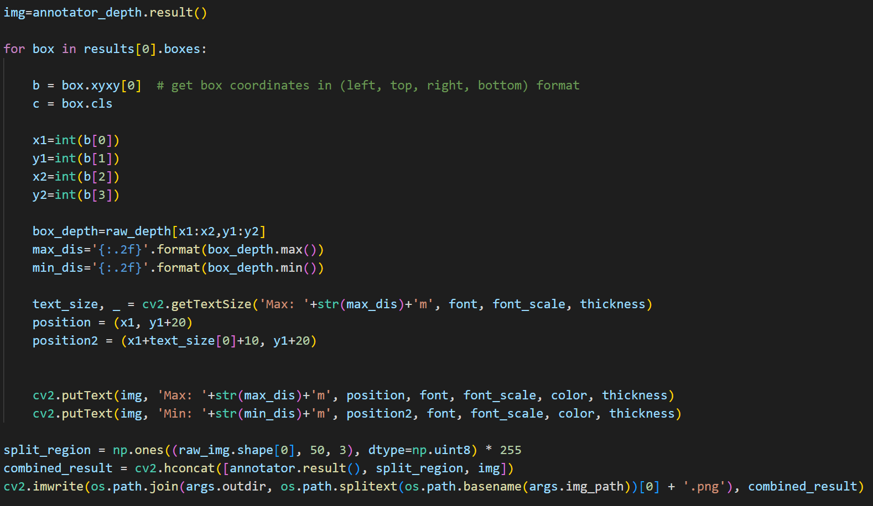 | Inference of Depth Estimation Model：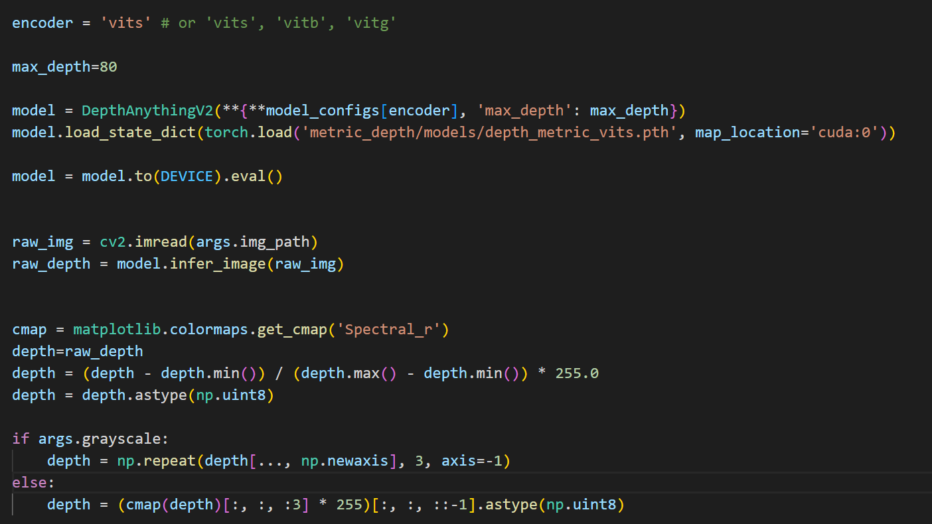

- Testing
  - Depth Estimation Effect Diagram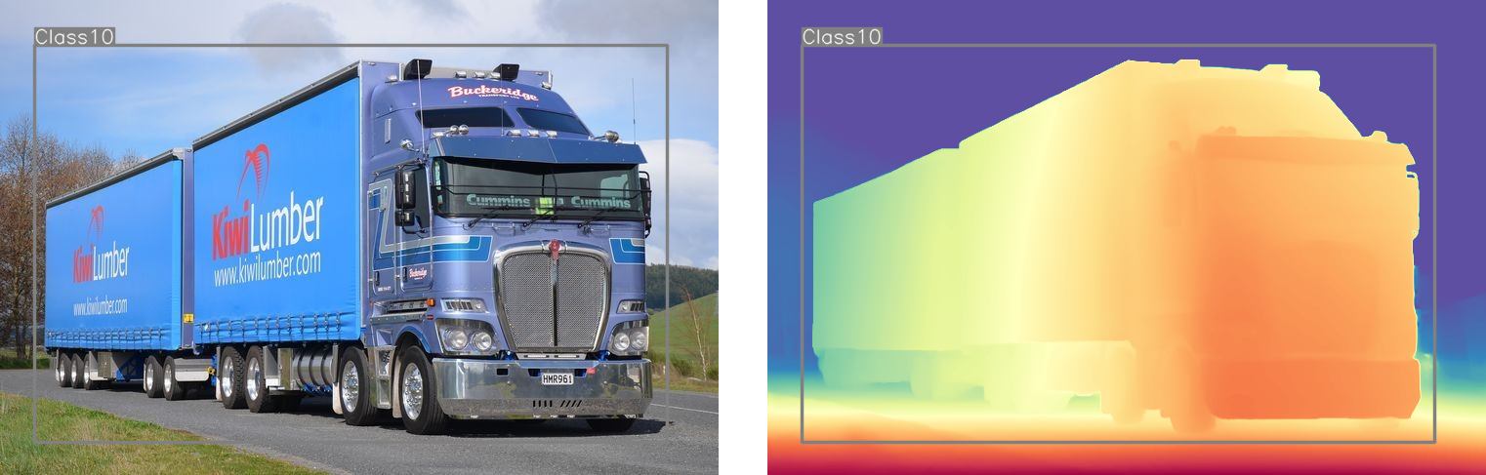
  - Estimation Results After Distance Calibration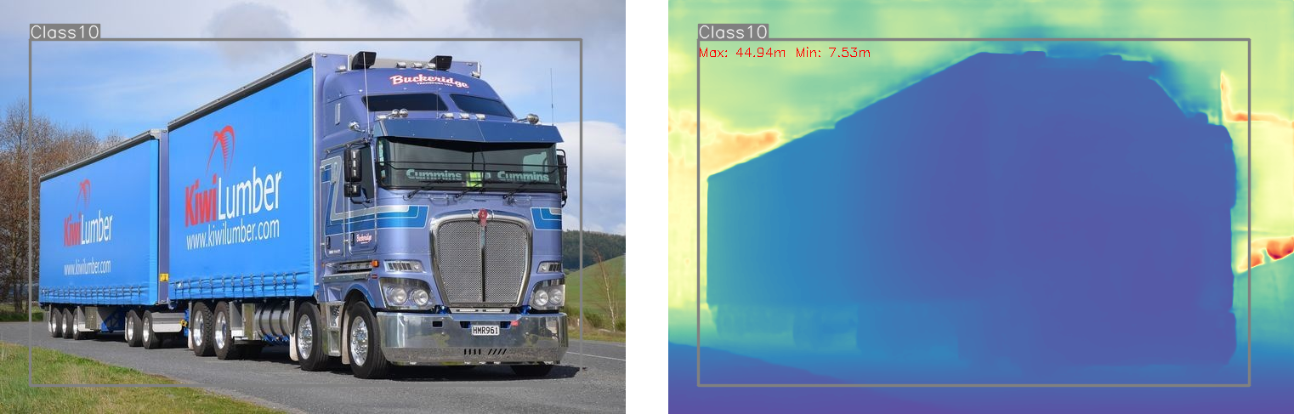
- Analysis and Outlook
  - Good Aspects: The combination of depth estimation based on a monocular camera and yolov8 is feasible, has the ability to measure distance, and is easy to deploy in the current road monitoring system.
  - Problems to be Solved:
    - Even for the model calibrated by distance, there are still signs of distortion in the distance performance. For example, the closest distance between the vehicle and the camera in the above figure is visually less than 7.5m, indicating that the camera needs to be calibrated or there needs to be an effective distance reference.
    - The target detection box determines the accuracy of the depth calculation area, and the offset of the box will lead to deviations in the area to be measured.
    - The target detection does not control the edges of the vehicle well, and there will be redundant areas. For example, the target box in the above figure includes the trees and the sky behind it. Perhaps the yolo-seg segmentation algorithm will achieve better results.
    - Depth estimation model is much bigger than yolov8, so the inference time is much longer. It needs a better GPU or some acceleration methods, such as TensorRT.

